AI-ENHANCED INTERIOR PERSONALIZATION USING DEEP LEARNING
A Mini Project Report
Submitted in partial fulfillment of the requirements for the award of the degree of

Bachelor of Engineering
in

Computer Science and Engineering
By

VAKA BHANU VAISHNAVI | 2456-23-733-418
BOBBA SRUJANA | 2456-22-733-075
RANA QUDSIYYAH ATMAKUR | 2456-22-733-118

Under the guidance of N.Meghana

Asst. Professor, CSE


DEPARTMENT OF COMPUTER SCIENCE AND ENGINEERING
Gokaraju Lailavathi Engineering College
(Affiliated to Osmania University, Approved by AICTE)
Nizampet, Hyderabad-500090 (2025-2026)
Department of Computer Science and Engineering
Gokaraju Lailavathi Engineering College
(Affiliated to Osmania University, Approved by AICTE)
Nizampet, Hyderabad-500090 (2024-2025)


CERTIFICATE
This is to Certify that a Mini Project report entitled “An Explainable Convolutional Neural Network Framework for Skin Lesion Classification with Risk-Aware Clinical Decision Support” is being submitted by Vaka Bhanu Vaishnavi(2456-23-733-418), Bobba Srujana (2456-22-733-075), Rana Qudsiyyah Atmakur (2456-22-733-118) in partial fulfillment of the requirement of the award for the degree of Bachelor of Engineering in “Computer Science and Engineering” O.U., Hyderabad during the year 2025-2026 is a record of bonafide work carried out by them under my guidance. The results presented in this project have been verified and are found to be satisfactory.

Project Guide H.O.D

N.Meghana Dr. Padmalaya Nayak
Asst. Professor, Professor & Head, Dept of CSE Dept. of CSE

External Examiner(s)


Department of Computer Science and Engineering
Gokaraju Lailavathi Engineering College
(Affiliated to Osmania University, Approved by AICTE)
Nizampet, Hyderabad-500090
(2025-2026)
DECLARATION
We, Vaka Bhanu Vaishnavi bearing Ht.No. 2456-23-733-418, Bobba Srujana bearing Ht.No.2456-22-733-075 and Rana Qudsiyyah Atmakur bearing Ht.No.2456-22-733-118 hereby certify that the minor project entitled “An Explainable Convolutional Neural Network Framework for Skin Lesion Classification with Risk-Aware Clinical Decision Support” is submitted in the partial fulfilment of the required for the award of the degree of Bachelor of Engineering in Computer Science and Engineering.
This is a record work carried out by us under the guidance of N.Meghana, Asst. Professor, CSE, Gokaraju Lailavathi Engineering College, Nizampet. The results embodied in this report have not been reproduced/copied from any source. The results embodied in this report have not been submitted to any other university or institute for the award of any other degree or diploma.

VAKA BHANU VAISHNAVI | 2456-23-733-418
BOBBA SRUJANA | 2456-22-733-075
RANA QUDSIYYAH ATMAKUR | 2456-22-733-118

ACKNOWLEDGEMENT

It is our privilege and pleasure to express my profound sense of respect, gratitude and indebtedness to our guide N.Meghana, Asst. Professor, Department of Computer Science and Engineering, Gokaraju Lailavathi Engineering College, for her inspiration, guidance, cogent discussion, constructive criticisms and encouragement throughout this dissertation work.
We express our sincere thanks to Project Coordinator Mr NandaKishore, Assistant Professor, Department of Computer Science and Engineering, Gokaraju Lailavathi Engineering College, for his valuable suggestions and constant helping in completing the work.
We express our sincere thanks to Dr. Padmalaya Nayak, Professor and Head of the Department of Computer Science and Engineering, Gokaraju Lailavathi Engineering College, for her valuable guidance, support and encouragement throughout the completion of this work.
We express our sincere thanks to Dr. A. Sai Hanuman, Principal, Gokaraju Lailavathi Engineering College, Nizampet, Hyderabad, for his encouragement and constant help.
We extend our sincere thanks to all the teaching and non-teaching staff of Computer Science and Engineering Department for their support and encouragement.
Last but not least, we wish to acknowledge my friends and family members for giving moral strength moral strength and helping us to complete this dissertation.

ABSTRACT

Skin diseases represent a significant global health concern, where early and accurate diagnosis is critical for effective treatment and prevention of severe outcomes. Traditional diagnostic approaches rely heavily on visual inspection by dermatologists, which can be subjective and prone to variability. This project proposes an explainable artificial intelligence framework for automated skin lesion classification using a Convolutional Neural Network (CNN) integrated with risk-aware clinical decision support. The proposed system classifies dermoscopic images into multiple categories, including benign, malignant, and basal cell lesions, while simultaneously providing visual explanations of model predictions through Gradient-weighted Class Activation Mapping (Grad-CAM). To improve practical usability, the framework further generates precautionary recommendations and guidance on when to seek medical consultation, thereby bridging the gap between automated prediction and real-world healthcare support. Additionally, the system is evaluated using standard performance metrics such as accuracy, precision, recall, and F1-score to ensure a comprehensive assessment of its classification effectiveness. The integration of explainability and risk-aware decision support makes the system more reliable and user-centric. This work highlights the potential of combining deep learning with explainable AI techniques to develop trustworthy and accessible tools for preliminary skin disease assessment.

CONTENTS

Chapter-1 INTRODUCTION 1
  - MOTIVATION… 1
  - PROBLEM STATEMENT 1
  - PROJECT OBJECTIVE 1
Chapter-2 LITERATURE SURVEY 2
  - A SURVEY ON AI-BASED SKIN LESION CLASSIFICATION 2
  - MOBILENETV2 AND CNN ARCHITECTURE IN LESION RECOGNITION 2
  - PREPROCESSING AND ARTIFACT REMOVAL IN DERMOSCOPIC IMAGING 2
  - MECHANISMS AND EXPLAINABILITY IN MEDICAL AI 3
  - CONCLUSION 3
Chapter-3 SOFTWARE REQUIREMENT SPECIFICATION 4
  - SOFTWARE REQUIREMENTS 4
  - HARDWARE REQUIREMENTS 4
  - FUNCTIONAL REQUIREMENTS 5
  - NON-FUNCTIONAL REQUIREMENTS 6
Chapter-4 SYSTEM DESIGN 7
  - SYSTEM DESIGN 7
  - PROPOSED METHODOLOGY 8
  - UML DESIGN 9
    - CLASS DIAGRAM… 11
    - USECASE DIAGRAM… 12
    - COMPONENT DIAGRAM… 13
    - SEQUENCE DIAGRAM… 14
    - ACTIVITY DIAGRAM 15
  - TECHNOLOGY DESCRIPTION 16
Chapter-5 IMPLEMENTATION 18
  - IMPLEMENTATION 18
  - MODULES 20
  - EXECUTABLE CODE 23
Chapter-6 RESULTS 38
Chapter-7 CONCLUSION 40
7.1 CONCLUSION… 40
7.1 FUTURE SCOPE… 40
REFERENCES 41
PLAGIARISM TEST… 42

SNO. | LIST OF FIGURES | PAGE NO.
4.2.1 | Proposed Methodology | 8
4.3.1 | UML Hierarchy Diagrams | 10
4.3.1.1 | Class Diagram | 11
4.3.2.1 | Use Case Diagram | 12
4.3.3.1 | Component Diagram | 13
4.3.4.1 | Sequence Diagram | 14
4.3.5.1 | Activity Diagram | 15
6.1 | User Input(Budget,image) | 38
6.2 | Recommended Output (Image) | 38

CHAPTER-1

INTRODUCTION

MOTIVATION
In response to the growing global burden of skin diseases and the limitations of traditional diagnostic methods, this project aims to provide an intelligent, patient‑centric solution for dermatological screening. Skin cancer and other lesions often go undetected in their early stages due to subjectivity in manual inspection, limited access to dermatologists, and variability in clinical expertise. Many patients struggle to recognize whether a lesion is benign or malignant, which can lead to delayed treatment, increased healthcare costs, or severe medical outcomes. By leveraging advanced deep learning models such as MobileNetV2 and integrating attention mechanisms like Squeeze‑and‑Excitation blocks, along with real‑time dermoscopic image preprocessing using OpenCV, this system empowers both clinicians and patients to make smarter health decisions. Through automated artifact removal, contrast enhancement, lesion classification, and risk‑aware clinical decision support, the project enhances not just diagnostic accuracy but also accessibility, usability, and efficiency. This AI‑driven approach bridges the gap between medical expertise and technology, making preliminary skin disease assessment more reliable, explainable, and widely available for everyone.

PROBLEM STATEMENT

Accurately identifying skin lesions can be confusing and time‑consuming—especially when patients or even general practitioners are unsure whether a lesion is benign, malignant, or requires urgent medical attention. Many individuals struggle to recognize how serious a lesion might be, or even what type of skin condition they are dealing with, which often leads to delayed consultations, misdiagnosis, or unnecessary anxiety. This project offers a smart solution: by simply uploading a dermoscopic image of the lesion, the system uses artificial intelligence to analyze the image, remove artifacts such as hairs, enhance contrast, and then classify the lesion into one of the standard dermatological categories (melanoma, nevus, basal cell carcinoma, etc.). Beyond classification, the framework integrates risk‑aware decision support, providing precautionary guidelines and referral triggers that align with clinical practice. It’s like having a virtual dermatology assistant that guides patients and clinicians with reliable, explainable predictions and actionable recommendations, making the diagnostic process more accessible, trustworthy, and efficient.

PROJECT OBJECTIVE
The goal of this project is to create a smart and easy‑to‑use dermatology assistant powered by artificial intelligence. By simply analyzing a dermoscopic image of a skin lesion, the system can remove artifacts such as hairs, enhance contrast for clearer visualization, and then classify the lesion into one of the standard medical categories. It not only identifies the lesion type but also provides risk‑aware clinical decision support, offering precautionary guidelines and referral triggers aligned with dermatological practice. Using advanced deep learning models like MobileNetV2 for feature extraction, Squeeze‑and‑Excitation blocks for attention enhancement, and Grad‑CAM for explainability, the project aims to make skin disease detection more accessible, faster, and trustworthy. By bridging AI technology with clinical needs, DermVision AI helps patients and healthcare providers make informed decisions, supports early diagnosis, and reduces subjectivity in dermatological screening—ultimately contributing to improved healthcare outcomes and wider accessibility.

CHAPTER 2 LITERATURE SURVEY

Skin lesion classification is a critical application of artificial intelligence in healthcare, as early detection of malignant conditions greatly improves patient survival. Traditional diagnosis depends on visual inspection, which is often subjective and inconsistent. Deep learning frameworks, particularly Convolutional Neural Networks (CNNs), provide automated solutions by learning features directly from dermoscopic images. Lightweight models like MobileNetV2 improve efficiency, while attention mechanisms such as Squeeze‑and‑Excitation blocks enhance focus on lesion regions. To build trust, explainability methods like Grad‑CAM highlight the areas influencing predictions, making the system transparent and clinically useful.

A SURVEY ON AI-BASED SKIN LESION CLASSIFICATION
Artificial Intelligence and Deep Learning have been increasingly applied in dermatology to support early detection and diagnosis of skin conditions. Traditional diagnosis relies on manual inspection, which can be subjective and inconsistent. AI‑based systems address this by analyzing dermoscopic images, extracting features, and predicting lesion categories with high accuracy. Prior studies emphasize the importance of combining classification with explainability and clinical decision support to make these systems more trustworthy and useful in real healthcare settings.

MobileNetV2 and CNN Architectures in Lesion Recognition
Lightweight convolutional neural networks such as MobileNetV2 are widely used for medical image classification because they balance efficiency and accuracy. MobileNetV2 introduces inverted residuals and depthwise separable convolutions, which reduce computational cost while maintaining strong performance. This makes it suitable for real‑time applications and deployment in environments with limited resources, such as web or mobile platforms. In skin lesion recognition, MobileNetV2 serves as a backbone for feature extraction and classification..

Preprocessing and Artifact Removal in Dermoscopic Imaging

Dermoscopic images often contain artifacts such as hairs, uneven lighting, or noise that can interfere with accurate classification. Literature highlights the importance of preprocessing techniques like morphological operations (e.g., Blackhat kernel) for hair detection and inpainting for artifact removal. Contrast enhancement methods such as CLAHE (Contrast Limited Adaptive Histogram Equalization) are also effective in improving lesion visibility. These preprocessing steps ensure that the model focuses on relevant lesion features rather than distractions.

Mechanisms and Explainability in Medical AI
Attention mechanisms, such as Squeeze‑and‑Excitation (SE) blocks, have been shown to improve feature representation by adaptively reweighting channels, allowing the model to focus more on critical lesion regions. Explainability techniques like Grad‑CAM (Gradient‑weighted Class Activation Mapping) provide visual insights into model predictions, highlighting the areas of the image that influenced the decision. These methods increase trust among clinicians and patients, making AI systems more transparent and clinically aligned.

CONCLUSION

This project implements an explainable deep learning framework for skin lesion classification that supports risk‑aware clinical decision making. It utilizes MobileNetV2 as the backbone for efficient feature extraction, Squeeze‑and‑Excitation blocks to enhance attention on critical lesion regions, and Grad‑CAM to provide visual explanations of predictions. Preprocessing techniques such as hair removal and CLAHE are applied to improve image clarity and ensure reliable classification. Based on lesion type, risk level, and clinical relevance, the system generates precautionary guidelines, skincare recommendations, and medical advice to bridge the gap between automated prediction and real‑world healthcare support. The backend is built using Flask for processing and data management, while the frontend provides interactive visualization of results. A SQLite database is integrated to store patient history, feedback, and scan records for adaptive learning. The system delivers annotated outputs with classification results and decision support, offering a complete and intelligent dermatology assistance experience.

CHAPTER-3

SOFTWARE REQUIREMENT SPECIFICATION

This chapter gives an overview of the software and hardware components required for our project.

SOFTWARE REQUIREMENTS
Windows 11 OS or Ubuntu 20.04+
Python 3.10.7 or above
Visual Studio Code (IDE)
PyTorch (for deep learning model implementation)
Flask (for backend server)
Streamlit (for interactive frontend visualization)
OpenCV (for image preprocessing and artifact removal)
PIL (for image handling)
SQLite3 library (for database management)

HARDWARE REQUIREMENTS
Desktop/Laptop (Intel i7 processor or above, 16GB RAM, 64-bit OS)
SSD Storage (minimum 512 GB)
NVIDIA GPU (optional, for faster training and inference)
Standard webcam or dermoscopic image input device (for real‑time testing)

FUNCTIONAL REQUIREMENTS
These are the requirements that the end user specifically demands as basic facilities that the system should offer. All these functionalities need to be necessarily incorporated into the system as a part of the contract. These are represented or stated in the form of input to be given to the system, the operation performed and the output expected. They are basically the requirements stated by the user which one can see directly in the final product, unlike the non-functional requirements.
- Image Upload Module
- Preprocessing (Hair Removal + Contrast Enhancement)
- Lesion Classification (MobileNetV2 + SE Blocks)
- Explainability (Grad‑CAM Heatmap Generation)
- Risk‑Aware Clinical Decision Support (Precautions, Skincare, Medical Advice)
- Probability Distribution Visualization
- Patient History and Feedback Storage (SQLite Database)

NON-FUNCTIONAL REQUIREMENTS
These are basically the quality constraints that the system must satisfy according to the project contract. The priority or extent to which these factors are implemented varies from one project to other. They are also called non-behavioral requirements.
They basically deal with issues like:

Portability

Security

Maintainability

Reusability

Flexibility

Performance

CHAPTER-4 SYSTEM DESIGN

System Design

In this phase, the system and software design documents are prepared as per the requirement specification document. This helps define overall system architecture.
There are two kinds of design documents developed in this phase:

High-Level Design (HLD)
- Brief description and name of each module
- An outline about the functionality of every module
- Interface relationship and dependencies between modules
- Database tables identified along with their key elements
- Complete architecture diagrams along with technology details

Low-Level Design(LLD)
- Functional logic of the modules
- Database tables, which include type and size
- Complete detail of the interface
- Addresses all types of dependency issues
- Listing of error messages

PROPOSED METHODOLOGY:

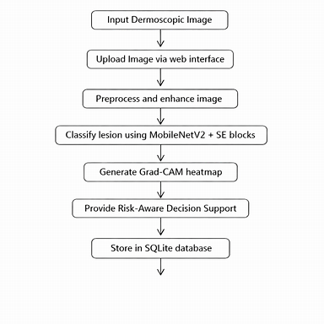

Figure-4.2.1 Proposed Methodology

UML Design:

Unified Modeling Language (UML) is a general purpose modeling language. The main aim of UML is to define a standard way to visualize the way a system has been designed.
UML is not a programming language; it is rather a visual language. We use UML diagrams to portray the behavior and structure of a system, UML helps software engineers, businessmen and system architects with modeling, design and analysis. The Object Management Group (OMG) adopted Unified Modeling Language as a standard in 1997. It’s been managed by OMG ever since. International Organization for Standardization (ISO) published UML as an approved standard in 2005. UML has been revised over the years and is reviewed periodically.

Do we really need UML?

- Complex applications need collaboration and planning from multiple teams and hence require a clear and concise way to communicate amongst them.
- Businessmen do not understand code. So UML becomes essential to communicate with non programmer’s essential requirements, functionalities and processes of the system.
- UML is linked with object oriented design and analysis. UML makes the use of elements and forms associations between them to form diagrams. Diagrams in UML can be broadly classified as:

The Primary goals in the design of the UML are as follows:

- Provide users a ready-to-use, expressive visual modeling Language so that they can develop and exchange meaningful models.
- Provide extendibility and specialization mechanisms to extend the core concepts.
- Be independent of particular programming languages and development process.
- Provide a formal basis for understanding the modeling language.
- Encourage the growth of OO tools market.
- Support higher level development concepts such as collaborations, frameworks, patterns and components.
- Integrate best practices.

Types of UML Diagrams:

Structural Diagrams:

Capture static aspects or structure of a system. Structural Diagrams include: Component Diagrams, Object Diagrams, Class Diagrams and Deployment Diagrams.

Behavior Diagrams:

Capture dynamic aspects or behavior of the system. Behavior diagrams include: Use Case Diagrams, State Diagrams, Activity Diagrams and Interaction Diagrams.

The image below shows the hierarchy of diagrams according to UML
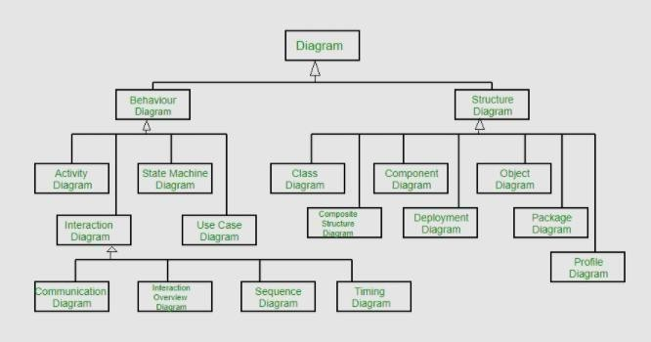

Figure-4.3.1 UML Hierarchy diagrams

CLASS DIAGRAM:
In software engineering, a class diagram in the Unified Modeling Language (UML) is a type of static structure diagram that describes the structure of a system by showing the system's classes, their attributes, operations (or methods), and the relationships among the classes. It explains which class contains information.
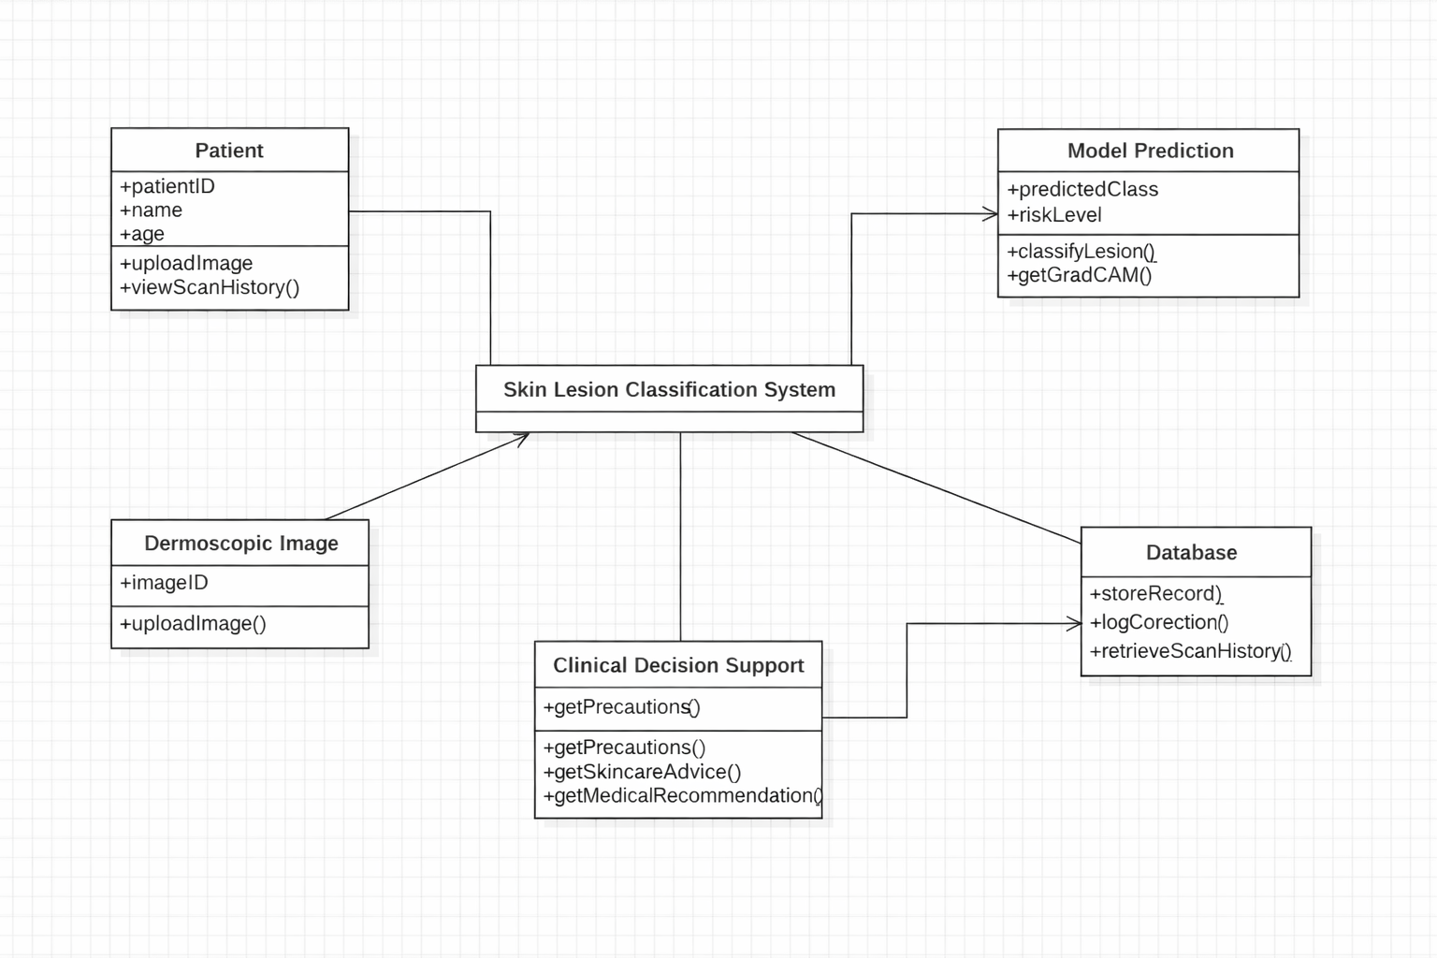Figure-4.3.1.1 Class Diagram

USE CASE DIAGRAM:
A use case diagram in the Unified Modeling Language (UML) is a type of behavioral diagram defined by and created from a Use-case analysis. Its purpose is to present a graphical overview of the functionality provided by a system in terms of actors, their goals (represented as use cases), and any dependencies between those use cases. The main purpose of a use case diagram is to show what system functions are performed for which actor. Roles of the actors in the system can be depicted.
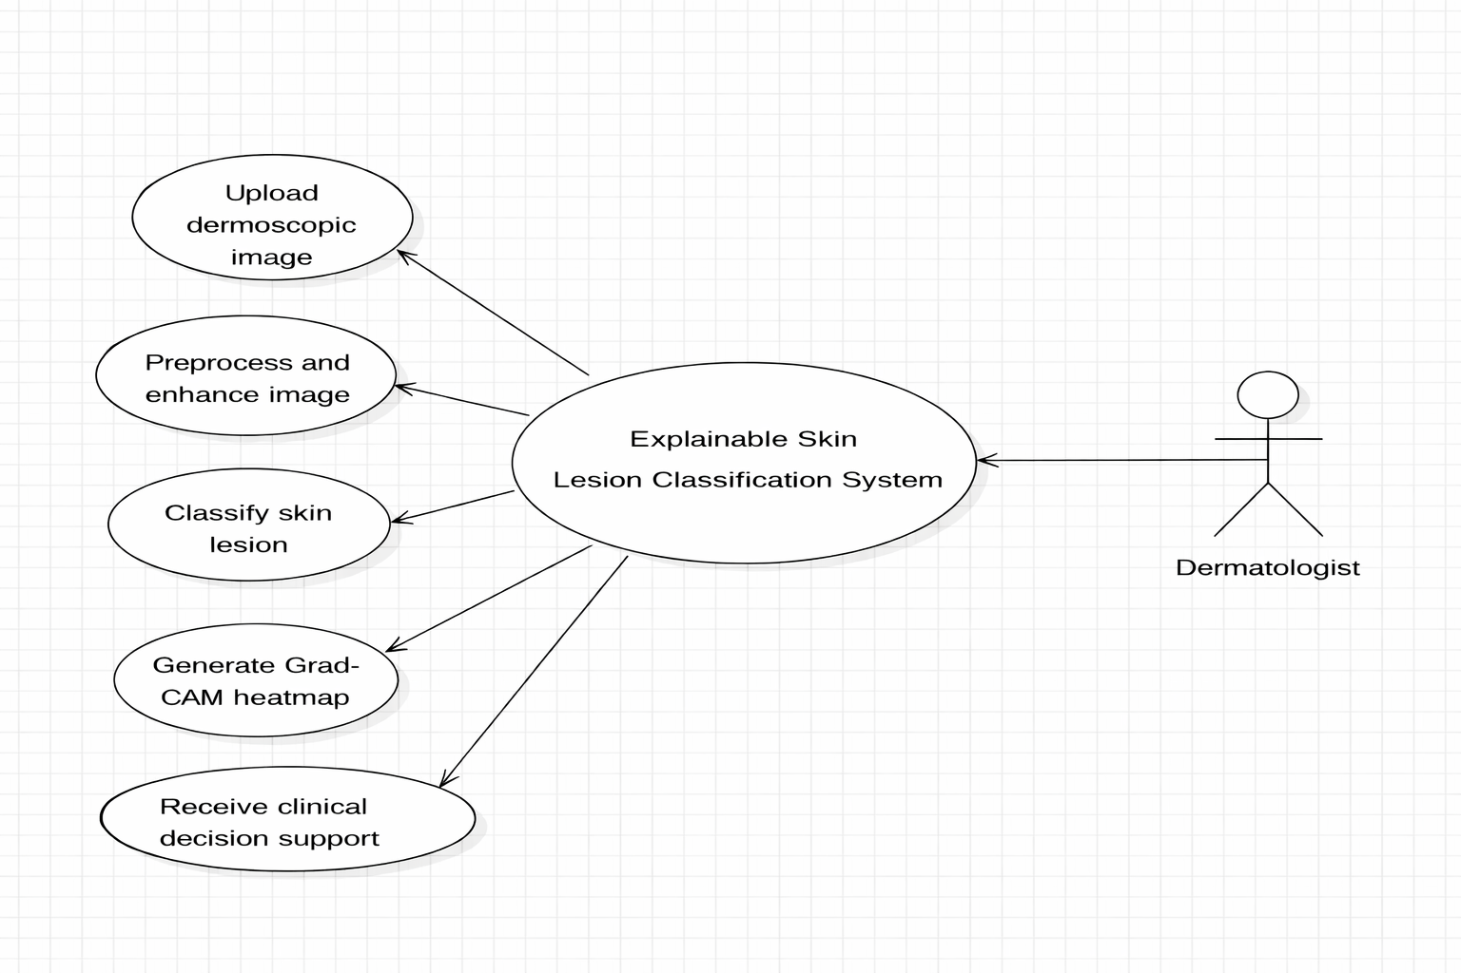
Figure-4.3.2.1 Use Case Diagram

COMPONENT DIAGRAM:
A component diagram, also known as a UML component diagram, describes the organization and wiring of the physical components in a system. Component diagrams are often drawn to help model implementation details and double-check that every aspect of the system's required functions is covered by planned development.

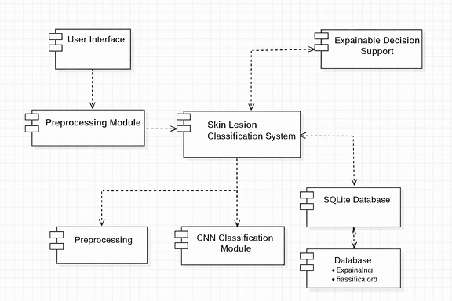

Figure-4.3.3.1 Component Diagram

SEQUENCE DIAGRAM:
A sequence diagram in Unified Modeling Language (UML) is a kind of interaction diagram that shows how processes operate with one another and in what order. It is a construct of a Message Sequence Chart. Sequence diagrams are sometimes called event diagrams, event scenarios, and timing diagrams.

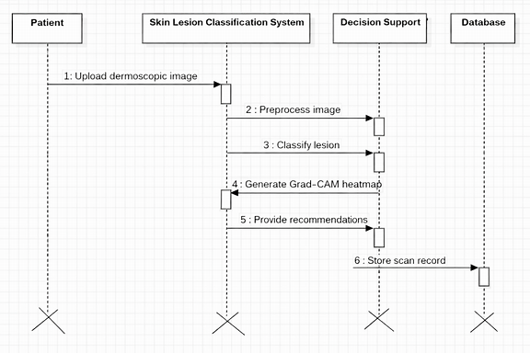

Figure-4.3.4.1 Sequence Diagram

ACTIVITY DIAGRAM:
In UML, an activity diagram is used to display the sequence of activities. Activity diagrams show the workflow from a start point to the finish point detailing the many decision paths that exist in the progression of events contained in the activity.

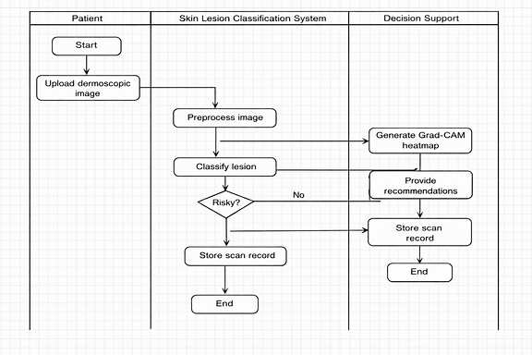
Figure-4.3.5.1 Activity Diagram

TECHNOLOGY DESCRIPTION

Streamlit
This system is designed to be simple and user‑friendly for patients and clinicians. You can upload dermoscopic images directly through the interface, and the AI will process them in real time. The tool displays annotated outputs with Grad‑CAM heatmaps, probability scores, and clinical recommendations, making it easy to understand what the system is suggesting. Interactive features allow users to view results clearly, and the session keeps track of uploaded scans so progress isn’t lost.

Flask
The backend acts as the engine of the system, handling all the heavy computations behind the scenes. When an image is uploaded, Flask manages preprocessing, classification, and explainability tasks. It connects the frontend with the deep learning models and the database, ensuring smooth communication. It takes care of routing requests, running inference, and returning results quickly and securely.

SQLite
The database works like the system’s memory. It stores patient scan records, classification outputs, Grad‑CAM visualizations, and clinical recommendations. This allows the system to maintain history, so clinicians can review past scans and compare results over time. It ensures data persistence and supports adaptive learning by keeping track of corrections or updates.

MobileNetV2 + SE Blocks
This deep learning model acts as the brain of the system. It analyzes dermoscopic images and classifies skin lesions into categories with associated risk levels. The SE (Squeeze‑and‑Excitation) blocks improve feature extraction, making predictions more accurate and reliable. This ensures the system can handle complex lesion patterns efficiently.

Grad‑CAM (Explainability)
Grad‑CAM provides visual explanations by highlighting the regions of the image that influenced the model’s decision. This makes the system transparent and trustworthy, allowing clinicians to see why a lesion was classified in a certain way. It bridges the gap between AI predictions and human understanding.

OpenCV & PIL
OpenCV is used for fast image preprocessing tasks such as resizing, noise removal, and contrast enhancement. PIL complements this by handling text overlays and polished visual outputs, ensuring that annotations and labels look clear and professional. Together, they make the image pipeline efficient and visually informative.

CHAPTER 5

IMPLEMENTATION

The implementation follows a modular and layered architecture that integrates deep learning models for lesion classification, a Flask backend for processing and data handling, and a Streamlit frontend for real‑time user interaction.

Image Upload & Processing

Patients or clinicians upload dermoscopic images through the Streamlit interface.
The Flask server receives the image and stores it in the local uploads/ directory.

Preprocessing Module (OpenCV & PIL)

Images are preprocessed to remove noise, enhance contrast, and normalize dimensions.
OpenCV handles fast operations like resizing and filtering.
PIL is used for polished overlays and annotations.

Lesion Classification (MobileNetV2 + SE Blocks)
The uploaded image is passed to the CNN model (MobileNetV2 enhanced with SE blocks).
The model predicts the lesion type and assigns a risk level (benign, suspicious, malignant).

Explainability (Grad‑CAM)
Grad‑CAM generates heatmaps highlighting the regions influencing the model’s decision.
These visual explanations are displayed alongside classification results to improve trust and transparency.

Risk‑Aware Clinical Decision Support

Based on classification and Grad‑CAM outputs, the system provides:

Precautionary measures

Skincare advice

Medical recommendations for further consultation

This ensures the AI acts as a supportive tool rather than a black‑box predictor.

User Interface Design(Streamlit)

Built for smooth and interactive web experience.

Main panel allows:

Uploading dermoscopic images

Viewing classification results and Grad‑CAM heatmaps

Accessing risk‑aware recommendations

Tracking session history of past uploads and results

Data Management with SQLite

Three tables are created:

history – logs patient sessions and classification outputs

results – stores lesion type, risk level, and Grad‑CAM visualizations

recommendations – saves clinical advice and precautionary measures

MODULES:

Image Upload Module

The Image Upload Module allows patients or clinicians to easily upload dermoscopic images. On the backend, Flask handles file processing—accepting formats like .jpg, .png, or .jpeg and saving them securely in an uploads/ folder. On the frontend, Streamlit provides a simple interface for selecting and submitting images, ensuring they are properly received and ready for analysis.

Preprocessing Module

The Preprocessing Module prepares images for accurate classification. It uses OpenCV to remove noise, resize, and enhance contrast, while PIL is used for polished overlays and annotations. This ensures that the input images are standardized and optimized before being passed to the deep learning model.

Lesion Classification Module
The Lesion Classification Module acts as the core intelligence of the system. It uses MobileNetV2 enhanced with SE blocks to classify dermoscopic images into lesion categories and assign risk levels. This module ensures fast, accurate, and reliable predictions.

Explainability Module (Grad‑CAM)

The Explainability Module generates Grad‑CAM heatmaps that highlight the regions of the image influencing the model’s decision. This makes the system transparent and trustworthy, allowing clinicians to visually understand why a lesion was classified in a certain way.
Risk‑Aware Decision Support Module
This module provides clinical recommendations based on classification results. It offers precautionary measures, skincare advice, and medical guidance, ensuring that the system supports doctors and patients with actionable insights rather than just raw predictions.

Frontend Interface Module

The Frontend Interface Module, built with Streamlit, is the interactive web app where users perform all tasks. It allows image uploads, displays classification results, shows Grad‑CAM visualizations, and provides clinical recommendations. It also maintains session history so users can revisit past scans and results.

Data Storage Module (SQLite)

The Data Storage Module acts as the system’s memory. It stores patient scan records, classification outputs, Grad‑CAM visualizations, and recommendations.

Three main tables are maintained:

history – logs patient sessions and uploaded images

results – stores lesion type, risk level, and Grad‑CAM outputs

recommendations – saves precautionary and clinical advice.

EXECUTABLE CODE

app.py(Frontend code)

import os

import base64

import numpy as np

try:

import cv2

CV2_AVAILABLE = True

except ImportError:

CV2_AVAILABLE = False

from PIL import Image

import sqlite3

from flask import Flask, request, jsonify, render_template

# Import our image preprocessing pipeline

from utils import preprocess_pipeline

# Try to import PyTorch and our model definition

PYTORCH_AVAILABLE = False

try:

import torch

import torch.nn as nn

import torchvision.transforms as transforms

from model import get_model

PYTORCH_AVAILABLE = True

except ImportError:

pass

app = Flask(__name__)

# Config

UPLOAD_FOLDER = 'uploads'

app.config['UPLOAD_FOLDER'] = UPLOAD_FOLDER

os.makedirs(UPLOAD_FOLDER, exist_ok=True)

# SQLite Database setup for Scan History

DATABASE = 'scans.db'

def init_db():

conn = sqlite3.connect(DATABASE)

cursor = conn.cursor()

cursor.execute('''

CREATE TABLE IF NOT EXISTS scans (

id INTEGER PRIMARY KEY AUTOINCREMENT,

timestamp DATETIME DEFAULT CURRENT_TIMESTAMP,

predicted_class TEXT NOT NULL,

predicted_key TEXT NOT NULL,

probability REAL NOT NULL,

risk_level TEXT NOT NULL,

type TEXT NOT NULL,

description TEXT NOT NULL,

original_image TEXT NOT NULL,

enhanced_image TEXT NOT NULL

)

''')

conn.commit()

conn.close()

init_db()

# Helper function to encode OpenCV image to base64

def encode_img_to_base64(img):

if not CV2_AVAILABLE:

return ""

_, buffer = cv2.imencode('.png', img)

return base64.b64encode(buffer).decode('utf-8')

# Skin Disease metadata and decision support recommendations

DISEASE_DATA = {

"mel": {

"name": "Melanoma",

"type": "Malignant (High Risk)",

"risk_level": "High",

"description": "A serious form of skin cancer that begins in the cells (melanocytes) that control skin pigment. It is highly curable if detected early, but can spread to other parts of the body if left untreated.",

"precautions": [

"Do NOT scratch, pick, or irritate the lesion.",

"Avoid all direct sun exposure and tanning beds.",

"Schedule a professional skin biopsy immediately."

],

"skincare": [

"Keep the skin barrier hydrated with gentle, fragrance-free moisturizers.",

"Always apply a broad-spectrum mineral sunscreen (SPF 50+) if exposed to light.",

"Avoid chemical peels or abrasive scrubs on the affected area."

],

"medical_advice": "CRITICAL: Seek immediate evaluation from a board-certified dermatologist. This condition requires a professional biopsy and surgical excision. Watch closely for the ABCDE rules of skin cancer."

},

"bcc": {

"name": "Basal Cell Carcinoma",

"type": "Malignant / Locally Invasive (Medium-High Risk)",

"risk_level": "Medium-High",

"description": "The most common form of skin cancer, which begins in the basal cells of the epidermis. It grows very slowly and rarely spreads, but can cause localized tissue damage if neglected.",

"precautions": [

"Do not attempt to squeeze, pop, or scratch the lesion.",

"Shield the area from direct sunlight.",

"Schedule a consultation for dermatological evaluation."

],

"skincare": [

"Cleanse the skin with mild, soap-free cleansers.",

"Maintain the skin barrier with ceramide-based moisturizers.",

"Apply SPF 30+ sunscreen daily to prevent localized growth stimulation."

],

"medical_advice": "IMPORTANT: Consult a dermatologist to discuss removal options, which include surgical excision, Mohs micrographic surgery, or cryosurgery. Basal Cell Carcinoma should be professionally treated to prevent deep tissue invasion."

},

"akiec": {

"name": "Actinic Keratosis (Pre-Cancerous)",

"type": "Pre-Malignant (Medium Risk)",

"risk_level": "Medium",

"description": "A rough, scaly patch on the skin that develops from years of sun exposure. It is considered pre-cancerous because it can progress to Squamous Cell Carcinoma (SCC) if left untreated.",

"precautions": [

"Strictly avoid sun exposure during peak hours.",

"Do not peel off or pick at the dry, scaly skin patches.",

"Check for other scaly lesions on sun-exposed areas (face, scalp, ears)."

],

"skincare": [

"Use thick, soothing emollients (like petrolatum or shea butter) to calm dryness.",

"Incorporate topical antioxidants (e.g., Niacinamide) to support skin repair.",

"Use broad-spectrum SPF 50+ sunscreen religiously before going outdoors."

],

"medical_advice": "RECOMMENDED: Visit a dermatologist for examination and treatment. Options include cryotherapy (freezing), topical chemotherapy creams (like 5-fluorouracil), or photodynamic therapy to clear the pre-cancerous cells."

},

"nv": {

"name": "Melanocytic Nevi (Common Mole)",

"type": "Benign (Low Risk)",

"risk_level": "Low",

"description": "A common, non-cancerous skin growth caused by clusters of melanocytes. Moles are normal skin features and generally harmless, though they should be monitored for changes.",

"precautions": [

"Monitor the mole monthly for changes in shape, size, border, or color.",

"Prevent sunburns, as they increase the risk of moles mutating.",

"Avoid friction or rubbing from tight clothing or jewelry."

],

"skincare": [

"Apply broad-spectrum SPF 30+ daily to all exposed skin.",

"Keep the skin healthy with general hydration and moisture.",

"No special clinical skincare is needed unless the mole is physically irritated."

],

"medical_advice": "ROUTINE: No immediate medical treatment is required. However, if the mole begins to bleed, itch, grow rapidly, or show irregular borders (asymmetry, color shifts), consult a dermatologist immediately."

},

"bkl": {

"name": "Benign Keratosis-like Lesions",

"type": "Benign (Low Risk)",

"risk_level": "Low",

"description": "Non-cancerous skin lesions, most commonly representing Seborrheic Keratosis. They typically have a waxy, 'stuck-on' appearance and are common in older adults.",

"precautions": [

"Avoid picking or scratching at the crust, which can lead to localized bleeding or infection.",

"Prevent friction from clothes, which can make the lesion red and irritated."

],

"skincare": [

"Soothe the area with light, non-comedogenic moisturizers.",

"Avoid using harsh chemical exfoliants (like glycolic or salicylic acid) directly on the growth.",

"Wash the area gently with a soft cloth."

],

"medical_advice": "ROUTINE: These growths are entirely harmless and do not turn into cancer. If they become irritated, catch on clothing, or are a cosmetic concern, a dermatologist can quickly remove them using cryotherapy or light curettage."

},

"vasc": {

"name": "Vascular Lesion",

"type": "Benign (Low Risk)",

"risk_level": "Low",

"description": "Benign lesions involving abnormal blood vessels. This includes cherry angiomas, hemangiomas, and pyogenic granulomas, which appear red, purple, or blue.",

"precautions": [

"Avoid trauma or picking at the site, as vascular lesions bleed very easily.",

"Avoid applying excessive heat or hot water to the area."

],

"skincare": [

"Use gentle cleansers and pat dry without rubbing.",

"Use simple, mild lotions to keep the skin surrounding the lesion hydrated."

],

"medical_advice": "ROUTINE: Generally harmless. If the lesion bleeds excessively, becomes painful, or grows rapidly (which can happen with pyogenic granulomas), seek clinical evaluation for treatment, which may include laser therapy or electrocautery."

},

"df": {

"name": "Dermatofibroma",

"type": "Benign (Low Risk)",

"risk_level": "Low",

"description": "A common, harmless, firm nodule that typically grows on the lower legs. They are often triggered by minor skin injuries like bug bites or shaving nicks.",

"precautions": [

"Avoid squeezing or trying to pop the nodule, as it is composed of fibrous scar tissue.",

"Be careful when shaving around the area to prevent cutting it."

],

"skincare": [

"Apply moisturizers to keep the skin smooth.",

"Use soothing creams if the nodule feels dry or slightly itchy."

],

"medical_advice": "ROUTINE: Dermatofibromas are benign and do not require treatment. If they are painful, itchy, or cosmetically undesirable, they can be surgically removed by a dermatologist, though this leaves a small scar."

}

}

# Mapping of labels to keys

LABEL_MAP = {

0: "akiec",

1: "bcc",

2: "bkl",

3: "df",

4: "mel",

5: "nv",

6: "vasc"

}

# Try loading the trained PyTorch model

model = None

if PYTORCH_AVAILABLE:

try:

model = get_model(num_classes=7)

if os.path.exists("skin_disease_model.pth"):

model.load_state_dict(torch.load("skin_disease_model.pth", map_location=torch.device('cpu')))

model.eval()

print("Successfully loaded PyTorch model weights from 'skin_disease_model.pth'")

else:

print("Model weights not found. Running PyTorch in unitialized state (will yield random predictions until trained).")

except Exception as e:

print(f"Error initializing PyTorch model: {e}. Model will fall back to simulated classification.")

model = None

# Transform for PyTorch inference

if PYTORCH_AVAILABLE:

inference_transform = transforms.Compose([

transforms.Resize((224, 224)),

transforms.ToTensor(),

transforms.Normalize(mean=[0.485, 0.456, 0.406], std=[0.229, 0.224, 0.225])

])

@app.route('/')

def index():

return render_template('index.html', pytorch_status=PYTORCH_AVAILABLE)

@app.route('/predict', methods=['POST'])

def predict():

if 'image' not in request.files:

return jsonify({'error': 'No image file uploaded'}), 400

file = request.files['image']

if file.filename == '':

return jsonify({'error': 'No file selected'}), 400

# Save uploaded file

file_path = os.path.join(app.config['UPLOAD_FOLDER'], file.filename)

file.save(file_path)

try:

# 1. Run the image preprocessing pipeline (Dull Razor + CLAHE)

processed_data = preprocess_pipeline(file_path)

# Base64 encode intermediate steps for frontend rendering

if processed_data.get('is_fallback', False):

steps_base64 = {

'original': processed_data['original'],

'grayscale': processed_data['grayscale'],

'blackhat': processed_data['blackhat'],

'hair_mask': processed_data['hair_mask'],

'hair_removed': processed_data['hair_removed'],

'enhanced': processed_data['enhanced']

}

else:

steps_base64 = {

'original': encode_img_to_base64(processed_data['original']),

'grayscale': encode_img_to_base64(processed_data['grayscale']),

'blackhat': encode_img_to_base64(processed_data['blackhat']),

'hair_mask': encode_img_to_base64(processed_data['hair_mask']),

'hair_removed': encode_img_to_base64(processed_data['hair_removed']),

'enhanced': encode_img_to_base64(processed_data['enhanced'])

}

# 2. Run Classification (PyTorch model or dynamic demo fallback)

probabilities = {}

predicted_key = ""

used_demo_mode = True

# Check if PyTorch is available and model is loaded successfully

if PYTORCH_AVAILABLE and model is not None:

try:

# Load preprocessed (enhanced) image for inference

pil_img = Image.fromarray(cv2.cvtColor(processed_data['enhanced'], cv2.COLOR_BGR2RGB))

tensor_img = inference_transform(pil_img).unsqueeze(0)

with torch.no_grad():

outputs = model(tensor_img)

probs = torch.softmax(outputs, dim=1)[0].numpy()

# Format output

for i, prob in enumerate(probs):

key = LABEL_MAP[i]

probabilities[key] = float(prob)

predicted_idx = int(np.argmax(probs))

predicted_key = LABEL_MAP[predicted_idx]

used_demo_mode = False

except Exception as inference_error:

print(f"PyTorch inference error: {inference_error}. Falling back to demo mode.")

# Dynamic Demo Mode / Fallback Classification

if used_demo_mode:

# We want to make the prediction look realistic and deterministic for the same image.

if CV2_AVAILABLE and not processed_data.get('is_fallback', False):

# We can compute the average color/brightness of the lesion to select a classification dynamically.

img_hsv = cv2.cvtColor(processed_data['enhanced'], cv2.COLOR_BGR2HSV)

avg_hue = np.mean(img_hsv[:, :, 0])

avg_sat = np.mean(img_hsv[:, :, 1])

avg_val = np.mean(img_hsv[:, :, 2])

score = (avg_hue * 0.3 + avg_sat * 0.4 + avg_val * 0.3)

else:

# Deterministic hash score based on file name length and characters

score = abs(hash(file.filename))

# Deterministic selection based on score

class_keys = list(DISEASE_DATA.keys())

predicted_idx = int(score) % len(class_keys)

predicted_key = class_keys[predicted_idx]

# Generate realistic probability distribution (highest for the predicted class)

probs = np.random.dirichlet(np.ones(len(class_keys)) * 2) # smooth distribution

max_idx = np.argmax(probs)

# Swap max probability to our predicted key

predicted_key_idx = class_keys.index(predicted_key)

probs[max_idx], probs[predicted_key_idx] = probs[predicted_key_idx], probs[max_idx]

for i, key in enumerate(class_keys):

probabilities[key] = float(probs[i])

# 3. Compile the response

prediction_info = DISEASE_DATA[predicted_key]

# Format prediction distributions for rendering

results_distribution = []

for key, prob in probabilities.items():

results_distribution.append({

'key': key,

'name': DISEASE_DATA[key]['name'],

'risk_level': DISEASE_DATA[key]['risk_level'],

'probability': round(prob * 100, 2)

})

# Sort by probability descending

results_distribution = sorted(results_distribution, key=lambda x: x['probability'], reverse=True)

response = {

'success': True,

'demo_mode': used_demo_mode,

'predicted_class': prediction_info['name'],

'predicted_key': predicted_key,

'risk_level': prediction_info['risk_level'],

'type': prediction_info['type'],

'description': prediction_info['description'],

'precautions': prediction_info['precautions'],

'skincare': prediction_info['skincare'],

'medical_advice': prediction_info['medical_advice'],

'probability': round(probabilities[predicted_key] * 100, 2),

'distribution': results_distribution,

'images': steps_base64

}

# Insert into Scan History database

try:

conn = sqlite3.connect(DATABASE)

cursor = conn.cursor()

cursor.execute('''

INSERT INTO scans (predicted_class, predicted_key, probability, risk_level, type, description, original_image, enhanced_image)

VALUES (?, ?, ?, ?, ?, ?, ?, ?)

''', (

prediction_info['name'],

predicted_key,

round(probabilities[predicted_key] * 100, 2),

prediction_info['risk_level'],

prediction_info['type'],

prediction_info['description'],

steps_base64['original'],

steps_base64['enhanced']

))

conn.commit()

conn.close()

except Exception as db_err:

print(f"Database insertion error: {db_err}")

# Clean up uploaded file

if os.path.exists(file_path):

os.remove(file_path)

return jsonify(response)

except Exception as e:

# Clean up uploaded file in case of error

if os.path.exists(file_path):

os.remove(file_path)

return jsonify({'error': str(e)}), 500

@app.route('/history', methods=['GET'])

def get_history():

try:

conn = sqlite3.connect(DATABASE)

conn.row_factory = sqlite3.Row

cursor = conn.cursor()

cursor.execute('SELECT id, timestamp, predicted_class, predicted_key, probability, risk_level, type, description, original_image, enhanced_image FROM scans ORDER BY timestamp DESC LIMIT 20')

rows = cursor.fetchall()

history_list = []

for row in rows:

history_list.append({

'id': row['id'],

'timestamp': row['timestamp'],

'predicted_class': row['predicted_class'],

'predicted_key': row['predicted_key'],

'probability': row['probability'],

'risk_level': row['risk_level'],

'type': row['type'],

'description': row['description'],

'original_image': row['original_image'],

'enhanced_image': row['enhanced_image']

})

conn.close()

return jsonify({'success': True, 'history': history_list})

except Exception as e:

return jsonify({'success': False, 'error': str(e)}), 500

@app.route('/history/delete/<int:scan_id>', methods=['POST'])

def delete_scan(scan_id):

try:

conn = sqlite3.connect(DATABASE)

cursor = conn.cursor()

cursor.execute('DELETE FROM scans WHERE id = ?', (scan_id,))

conn.commit()

conn.close()

return jsonify({'success': True, 'message': 'Scan deleted successfully'})

except Exception as e:

return jsonify({'success': False, 'error': str(e)}), 500

@app.route('/history/clear', methods=['POST'])

def clear_history():

try:

conn = sqlite3.connect(DATABASE)

cursor = conn.cursor()

cursor.execute('DELETE FROM scans')

conn.commit()

conn.close()

return jsonify({'success': True, 'message': 'History cleared successfully'})

except Exception as e:

return jsonify({'success': False, 'error': str(e)}), 500

if __name__ == '__main__':

print("Starting Skin Disease Classification Server...")

app.run(debug=True, port=5000)

backend.py(Backend code)

from flask import Flask, request, jsonify

from ultralytics import YOLO

import torch

from torchvision.models.segmentation import deeplabv3_resnet50

from efficientnet_pytorch import EfficientNet

from PIL import Image, ImageDraw, ExifTags

import cv2

import numpy as np

import pandas as pd

from sklearn.cluster import KMeans

import os

import sqlite3

from datetime import datetime

import json

import glob

app = Flask(_name_)

# Load models

try:

yolo_model = YOLO('yolov8n.pt') # Pre-trained YOLOv8

deeplab_model = deeplabv3_resnet50(pretrained=True).eval()

efficientnet_model = EfficientNet.from_pretrained('efficientnet-b0')

print("All models loaded successfully")

except Exception as e:

print(f"Warning: Could not load all models: {e}")

yolo_model = None

deeplab_model = None

efficientnet_model = None

# Room type detection keywords

ROOM_KEYWORDS = {

'bedroom': ['bed', 'mattress', 'pillow', 'wardrobe', 'dresser', 'nightstand'],

'living_room': ['sofa', 'couch', 'coffee table', 'tv', 'armchair', 'recliner'],

'dining_room': ['dining table', 'chair', 'dining', 'table', 'seater'],

'kitchen': ['kitchen', 'stove', 'refrigerator', 'sink', 'cabinet'],

'office': ['desk', 'computer', 'office chair', 'bookshelf', 'study'],

'outdoor': ['garden', 'patio', 'balcony', 'outdoor', 'swing', 'garden chair']

}

# Furniture categories and their room compatibility

FURNITURE_COMPATIBILITY = {

'bedroom': ['Bed', 'Wardrobes', 'Mattress', 'Furnishings', 'Home_Decor'],

'living_room': ['Sofa', 'Center_Table', 'Chairs', 'Recliner', 'Home_Decor', 'Furnishings'],

'dining_room': ['Dining', 'Chairs', 'Center_Table', 'Furnishings'],

'kitchen': ['Home_Decor', 'Furnishings'],

'office': ['Office', 'Chairs', 'Bookshelves', 'Home_Decor'],

'outdoor': ['Outdoor', 'Home_Decor']

}

# Initialize dataset

def load_dataset():

"""Load furniture dataset from the dataset directory"""

furniture_data = []

# Walk through all subdirectories in dataset

for category in os.listdir('dataset'):

category_path = os.path.join('dataset', category)

if os.path.isdir(category_path):

for subcategory in os.listdir(category_path):

subcategory_path = os.path.join(category_path, subcategory)

if os.path.isdir(subcategory_path):

# Get all images in this subcategory

images = glob.glob(os.path.join(subcategory_path, '*.jpg'))

for image_path in images:

# Extract information from path

filename = os.path.basename(image_path)

furniture_data.append({

'category': category,

'subcategory': subcategory,

'image_path': image_path,

'filename': filename

})

return pd.DataFrame(furniture_data)

# Load dataset

furniture_dataset = load_dataset()

print(f"Loaded {len(furniture_dataset)} furniture items")

# SQLite database for feedback and history

def init_db():

conn = sqlite3.connect('history.db')

c = conn.cursor()

c.execute('''CREATE TABLE IF NOT EXISTS history

(user_id TEXT, image_path TEXT, room_type TEXT, suggestions TEXT, timestamp TEXT)''')

c.execute('''CREATE TABLE IF NOT EXISTS feedback

(user_id TEXT, suggestion_id TEXT, rating INTEGER, comments TEXT, timestamp TEXT)''')

c.execute('''CREATE TABLE IF NOT EXISTS corrections (user_id TEXT, image_path TEXT, detected_room_type TEXT, corrected_room_type TEXT, timestamp TEXT)''')

conn.commit()

conn.close()

init_db()

@app.route('/upload_dataset', methods=['POST'])

def upload_dataset():

"""Endpoint to upload a dataset of images."""

if 'images' not in request.files:

return jsonify({'error': 'No images uploaded'}), 400

uploaded_files = request.files.getlist('images')

if not uploaded_files or all(file.filename == '' for file in uploaded_files):

return jsonify({'error': 'No selected image files'}), 400

dataset_dir = os.path.join('dataset', 'images')

os.makedirs(dataset_dir, exist_ok=True)

new_items = []

for file in uploaded_files:

if file and file.filename.lower().endswith(('.png', '.jpg', '.jpeg')):

image_path = os.path.join(dataset_dir, file.filename)

file.save(image_path)

new_items.append(image_path)

return jsonify({'status': 'Dataset uploaded successfully', 'items': len(new_items)})

@app.route('/upload', methods=['POST'])

def upload_image():

user_id = request.form.get('user_id', 'default_user')

budget = float(request.form.get('budget', 1000))

style_preference = request.form.get('style', 'modern')

override_room_type = request.form.get('override_room_type', None)

if 'image' not in request.files:

return jsonify({'error': 'No image uploaded'}), 400

image = request.files['image']

if image.filename == '':

return jsonify({'error': 'No selected file'}), 400

image_path = os.path.join('uploads', image.filename)

os.makedirs(os.path.dirname(image_path) or '.', exist_ok=True)

image.save(image_path)

was_already_corrected = False

try:

# Check for past corrections first

conn = sqlite3.connect('history.db')

c = conn.cursor()

c.execute('''CREATE TABLE IF NOT EXISTS corrections (user_id TEXT, image_path TEXT, detected_room_type TEXT, corrected_room_type TEXT, timestamp TEXT)''')

c.execute("SELECT corrected_room_type FROM corrections WHERE user_id = ? AND image_path = ? ORDER BY timestamp DESC LIMIT 1", (user_id, image_path))

past_correction = c.fetchone()

conn.close()

# Process image

room_analysis, suggestions, output_path = analyze_room_and_recommend(image_path, budget, style_preference)

detected_room_type = room_analysis['room_type']

effective_room_type = None

if override_room_type: # A new correction is being submitted

effective_room_type = override_room_type

# Save the new correction

conn = sqlite3.connect('history.db')

c = conn.cursor()

c.execute("INSERT INTO corrections (user_id, image_path, detected_room_type, corrected_room_type, timestamp) VALUES (?, ?, ?, ?, datetime('now'))", (user_id, image_path, detected_room_type, override_room_type))

conn.commit()

conn.close()

elif past_correction: # A past correction exists

effective_room_type = past_correction[0]

was_already_corrected = True

# If room type is overridden (past or present), re-generate suggestions

if effective_room_type:

room_analysis['room_type'] = effective_room_type

suggestions = get_furniture_recommendations(effective_room_type, room_analysis['room_size'], room_analysis['color_scheme'], budget, style_preference, room_analysis['existing_objects'])

except Exception as e:

return jsonify({'error': f'Processing failed: {str(e)}'}), 500

# Store in history

conn = sqlite3.connect('history.db')

c = conn.cursor()

c.execute("INSERT INTO history (user_id, image_path, room_type, suggestions, timestamp) VALUES (?, ?, ?, ?, datetime('now'))",

(user_id, image_path, room_analysis['room_type'], json.dumps(suggestions)))

conn.commit()

conn.close()

return jsonify({

'room_analysis': room_analysis,

'suggestions': suggestions,

'output_image': output_path,

'was_already_corrected': was_already_corrected

})

@app.route('/feedback', methods=['POST'])

def submit_feedback():

user_id = request.form.get('user_id', 'default_user')

suggestion_id = request.form.get('suggestion_id')

try:

rating = int(request.form.get('rating'))

except ValueError:

return jsonify({'error': 'Invalid rating'}), 400

comments = request.form.get('comments', '')

conn = sqlite3.connect('history.db')

c = conn.cursor()

c.execute("INSERT INTO feedback (user_id, suggestion_id, rating, comments, timestamp) VALUES (?, ?, ?, ?, datetime('now'))",

(user_id, suggestion_id, rating, comments))

conn.commit()

conn.close()

return jsonify({'status': 'success'})

@app.route('/history/<user_id>', methods=['GET'])

def get_history(user_id):

conn = sqlite3.connect('history.db')

c = conn.cursor()

c.execute("SELECT * FROM history WHERE user_id = ?", (user_id,))

history = c.fetchall()

conn.close()

return jsonify(history)

def analyze_room_and_recommend(image_path, budget, style_preference):

"""Analyze room and recommend furniture"""

# 1. Object Detection to identify existing furniture

existing_objects = []

if yolo_model:

try:

results = yolo_model(image_path)

existing_objects = [result.names[int(cls)] for result in results for cls in result.boxes.cls] if results else []

except Exception as e:

print(f"YOLO detection failed: {e}")

# 2. Room Type Detection

room_type = detect_room_type(existing_objects)

# 3. Room Size Analysis

room_size = analyze_room_size(image_path)

# 4. Color Analysis

color_scheme = analyze_color_scheme(image_path)

# 5. Get Recommendations

recommendations = get_furniture_recommendations(room_type, room_size, color_scheme, budget, style_preference, existing_objects)

# 6. Generate Output Image

output_path = generate_output_image(image_path, recommendations)

room_analysis = {

'room_type': room_type,

'room_size': room_size,

'color_scheme': color_scheme,

'existing_objects': existing_objects

}

return room_analysis, recommendations, output_path

def detect_room_type(existing_objects):

"""Detect room type based on existing objects"""

object_text = ' '.join(existing_objects).lower()

# Check for outdoor indicators

if any(keyword in object_text for keyword in ['garden', 'patio', 'balcony', 'outdoor', 'swing']):

return 'outdoor'

# Check for specific room types

for room_type, keywords in ROOM_KEYWORDS.items():

if room_type != 'outdoor': # Already checked

if any(keyword in object_text for keyword in keywords):

return room_type

# Default based on most common objects

if 'bed' in object_text or 'mattress' in object_text:

return 'bedroom'

elif 'sofa' in object_text or 'couch' in object_text:

return 'living_room'

elif 'dining' in object_text or 'table' in object_text:

return 'dining_room'

elif 'desk' in object_text or 'computer' in object_text:

return 'office'

else:

return 'living_room' # Default

def analyze_room_size(image_path):

"""Analyze room size from image"""

try:

image = Image.open(image_path)

width, height = image.size

# Simple size classification based on image dimensions

if width * height < 500000: # Small image

return 'small'

elif width * height < 1500000: # Medium image

return 'medium'

else:

return 'large'

except:

return 'medium'

def analyze_color_scheme(image_path):

"""Analyze dominant colors in the room"""

try:

image = Image.open(image_path).convert('RGB')

img_array = np.array(image).reshape(-1, 3)

kmeans = KMeans(n_clusters=5, random_state=42)

kmeans.fit(img_array)

dominant_colors = kmeans.cluster_centers_.astype(int)

# Convert to hex colors

hex_colors = ['#%02x%02x%02x' % tuple(color) for color in dominant_colors]

return hex_colors

except:

return ['#808080'] # Default gray

def get_furniture_recommendations(room_type, room_size, color_scheme, budget, style_preference, existing_objects):

"""Get furniture recommendations based on room analysis"""

recommendations = []

# Get compatible furniture categories

compatible_categories = FURNITURE_COMPATIBILITY.get(room_type, ['Home_Decor'])

# Filter dataset by compatible categories

compatible_items = furniture_dataset[furniture_dataset['category'].isin(compatible_categories)]

if len(compatible_items) == 0:

# Fallback to general decor items

compatible_items = furniture_dataset[furniture_dataset['category'] == 'Home_Decor']

# Select recommendations based on room size

num_recommendations = 3 if room_size == 'small' else 5 if room_size == 'medium' else 7

# Get random recommendations

if len(compatible_items) > 0:

selected_items = compatible_items.sample(min(num_recommendations, len(compatible_items)))

for _, item in selected_items.iterrows():

# Generate estimated price based on category and style

base_price = get_base_price(item['category'], item['subcategory'])

estimated_price = min(base_price, budget * 0.3) # Max 30% of budget per item

recommendation = {

'category': item['category'],

'subcategory': item['subcategory'],

'name': f"{item['subcategory'].replace('_', ' ')}",

'price': estimated_price,

'image_path': item['image_path'],

'compatibility_score': calculate_compatibility_score(item, room_type, style_preference)

}

recommendations.append(recommendation)

# Sort by compatibility score

recommendations.sort(key=lambda x: x['compatibility_score'], reverse=True)

return recommendations[:num_recommendations]

def get_base_price(category, subcategory):

"""Get base price for furniture category"""

price_ranges = {

'Bed': {'King_With_Storage': 800, 'Queen_With_Storage': 600, 'Single_Bed': 300},

'Sofa': {'Fabric_Sofa': 500, 'Leather_Sofas': 800, 'Sofa_Sets': 1200},

'Chairs': {'Computer_Chairs': 200, 'Office_Chairs': 300, 'Visitor_Chairs': 150},

'Center_Table': {'Wooden_Center_Tables': 250, 'Glass_Center_Tables': 300},

'Dining': {'Four_Seater': 400, 'Six_Seater': 600, 'Eight_Seater': 800},

'Wardrobes': {'Two_Door': 400, 'Three_Door': 600, 'Four_Door': 800},

'Home_Decor': {'Lighting': 100, 'Wall_Decor': 80, 'Table_Decor': 60},

'Furnishings': {'Curtains': 120, 'Bed_Linen': 80, 'Cushions_Covers': 40}

}

return price_ranges.get(category, {}).get(subcategory, 200)

def calculate_compatibility_score(item, room_type, style_preference):

"""Calculate compatibility score for furniture item"""

score = 0.5 # Base score

# Room type compatibility

if item['category'] in FURNITURE_COMPATIBILITY.get(room_type, []):

score += 0.3

# Style preference (simplified)

if style_preference.lower() in item['subcategory'].lower():

score += 0.2

return score

def generate_output_image(image_path, recommendations):

"""Generate output image with recommendations overlaid"""

try:

image = Image.open(image_path).convert('RGB')

draw = ImageDraw.Draw(image)

# Add recommendations text

y_offset = 20

for i, rec in enumerate(recommendations):

text = f"{i+1}. {rec['name']} - ${rec['price']}"

draw.text((10, y_offset), text, fill="white", stroke_width=2, stroke_fill="black")

y_offset += 25

# Save output

output_filename = f"output_{os.path.basename(image_path).split('.')[0]}{datetime.now().strftime('%Y%m%d%H%M%S')}.jpg"

output_path = os.path.join('uploads', output_filename)

image.save(output_path)

return output_path

except Exception as e:

print(f"Error generating output image: {e}")

return image_path

if _name_ == '_main_':

app.run(debug=True, host='0.0.0.0', port=5000)

CHAPTER -6

RESULTS
- After running the program we can see the following results

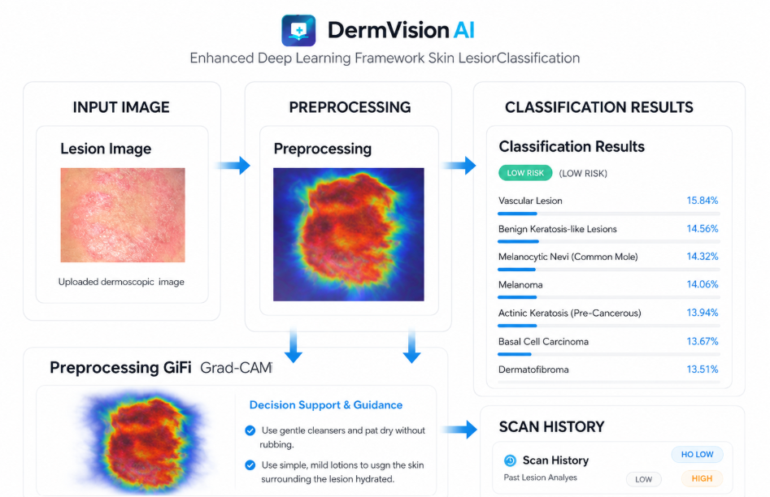

CHAPTER 7

7.1 CONCLUSION

This project implements a deep learning‑based skin lesion classification system that analyzes dermoscopic images and provides risk‑aware clinical decision support. It utilizes MobileNetV2 with SE blocks for accurate lesion classification, while Grad‑CAM is applied to generate explainable heatmaps that highlight the regions influencing the model’s decision. Preprocessing techniques using OpenCV and PIL enhance image quality for better predictions. Based on lesion type, risk level, and clinical metadata, the system provides personalized recommendations including precautions, skincare advice, and medical guidance. The backend is built using Flask, while the frontend is developed with Streamlit for real‑time interaction and visualization. An SQLite database is integrated to store patient history, scan results, and recommendations for adaptive learning. The system generates annotated outputs with classification results and explainability, offering a complete and intelligent clinical support experience.

7.2 FUTURE SCOPE
Integration with Electronic Health Records (EHR): Future versions can connect with hospital databases to automatically store and retrieve patient scan history, making the system more clinically useful.
Mobile Application Deployment: A lightweight mobile app can allow patients to upload dermoscopic images directly from smartphones, increasing accessibility in remote areas.
Tele‑Dermatology Support: The system can be extended to share results securely with dermatologists, enabling remote consultations and faster second opinions.
Augmented Reality (AR) Visualization: AR could be used to overlay lesion risk information directly on patient skin images, making diagnosis more interactive and immersive.
Voice‑Based Clinical Assistance: By integrating with voice assistants, doctors could query lesion details or recommendations hands‑free during examinations.
3D Lesion Modeling: The system can evolve to reconstruct lesions in 3D from 2D dermoscopic images, helping clinicians better understand lesion depth and structure.

REFERENCES
Jonathan Vieira, Fábio Mendonça, Fernando Morgado‑Dias, “Deep Learning Approaches for Skin Lesion Detection”, Electronics, Vol. 14, Issue 14, pp. 2785, July 2025.
– Benchmarks 38 CNN architectures (ConvNeXt, EfficientNet, MobileNet, ResNet, etc.) on HAM10000 and ISIC datasets, achieving 87.62% accuracy with ConvNeXtXLarge.

“An Overview of Artificial Intelligence Based Skin Lesion Analysis for Dermatologists”, IEEE Conference Publication, 2024.
– Provides a comprehensive review of AI techniques for dermatology, highlighting CNNs, transfer learning, and clinical integration.

“Advancing Radiological Dermatology with an Optimized Ensemble Deep Learning Model for Skin Lesion Classification”, Computer Modeling in Engineering and Sciences (CMES)

PLAGIARISM TEST

